Dear All,

We would like to raise awareness of a recent threat to our nighttime environment and ask for your help.

Reflect Orbital is a start-up company proposing a constellation of satellites (50,000 by 2035!) to provide a sunlight-on-demand service to consumers. This would involve reflecting beams of sunlight with ~5 km in diameter onto Earth’s surface to provide lighting/energy to the customer. They claim that this infrastructure will provide clean energy and lighting.

They also claim that the beams a) will be highly localized, b) can “avoid sensitive areas like research observatories or protected habitats”, and c) will not harm eyes, “even when viewed through a telescope”. We are skeptical of all of these points, and we are very concerned about the many harmful effects this satellite constellation would have, such as:

- The adverse impacts on human health by disrupting circadian rhythms.
- Disruption of the flora and fauna at night; ethology, migration, hunting, hiding, etc. Wildlife cannot adapt to a major, sudden departure from the existing rhythm of day/night cycles in a given area.
- Further degradation of the night sky for the public due to increased skyglow and light pollution.
- Potential safety hazards for aviation, from bright glints as the beams turn on and off, or to airplanes when they fly through the floodlit zones.
- The impact on dark sky protection and astronomical observations.
- The environmental impact of launching 50,000 satellites, including from rocket launches, satellite de-orbiting, and the associated orbital debris.

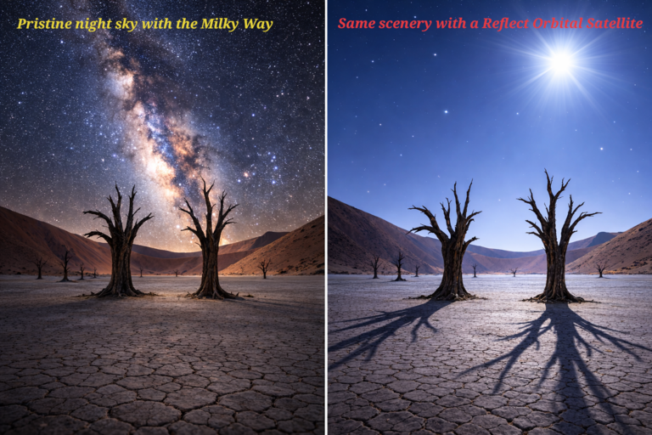

Some additional remarks:

- Everyone within these 5km-diameter spots will be affected. Light will fall on anything with the circle of illumination - on your roof, backyard, local forest, and beyond. This is exactly the opposite of responsible outdoor lighting.
- Rayleigh scattering in the atmosphere, both from the incoming beam and from reflected light, is ignored by the company, and results in an enormous skyglow from a brightly illuminated area the size of 650 football stadiums. This technology will introduce sustained artificial dusk and dawn conditions across landscapes, in addition to hours-long bursts of daytime brightness.
- Paradoxically, “clean energy” is used here to cause environmental damage. (What if we used wind-power to drive oil wells or solar panels to charge coal-mining trucks?)
- Currently, at least 75% of nighttime lighting on Earth is wasted through overlighting, trespass, and uplight. The largest positive impact on our environment would come from eliminating this 75%.

Reflect Orbital has submitted an application to the Federal Communications Commission (FCC) to launch a testing satellite, EARENDIL-1. Their demonstration satellite would produce a beam about as bright as the full Moon, while the full constellation could produce illumination comparable to that of the Sun at high noon. The FCC has opened a public comment period until March 9th, 2026, giving the public an opportunity to voice their thoughts and concerns about federally approved projects.

As it stands, there are barely any comments, and their proposal will sail through the FCC.

We therefore have three asks of you:
- Please sign and share the open letter opposing this project, written by DarkSky International. Signing takes less than 30 seconds and only requires you to enter your name and email address.

- Please sign and share this change.org petition advocating against Reflect Orbital. This also only requires you to enter your name and email, and takes another half a minute.

- Please consider submitting a public comment to the FCC by March 9th. There are a few steps to do this, which we have tried to make as easy as possible for others to replicate:
  - Copy and fill in a template public comment if you do not want to write your own. We have written one you can use (attached), or DarkSky International has one here. If possible, personalize the comment to increase its impact.
  - Create an FCC User account (you just need to enter your name and email, choose a password, and select a security question). This is a bit of a hassle, but that is partly why the FCC has so few comments opposing this project. Please fight through!
  - To submit the public comment, find instructions here by AAS, which includes screenshots of navigating the FCC website, or here by DarkSky (using “Reflect Orbital proposal: SAT-LOA-20250701-00129”).

Please let us know if you have any questions, want to discuss further, or want to get involved.

Best wishes,

Sarah Thiele & Gaspar Bakos

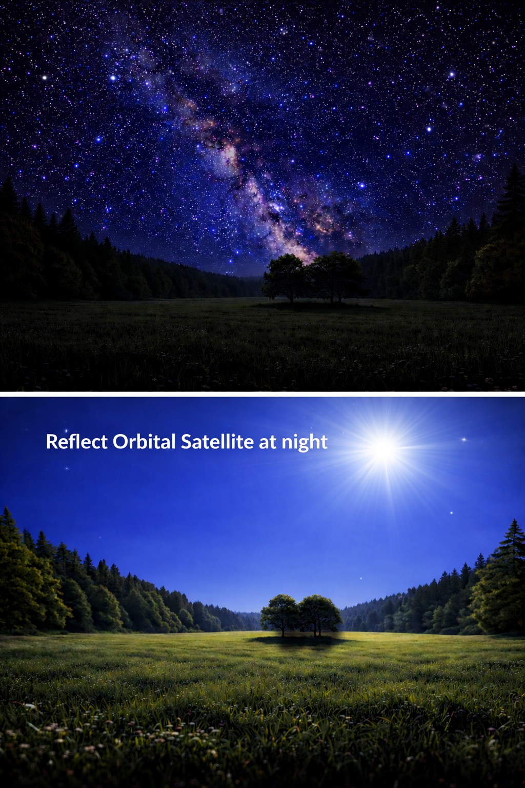
A simulation of a reflectorbital satellite beaming light at night-time.

